Use Case Specifications
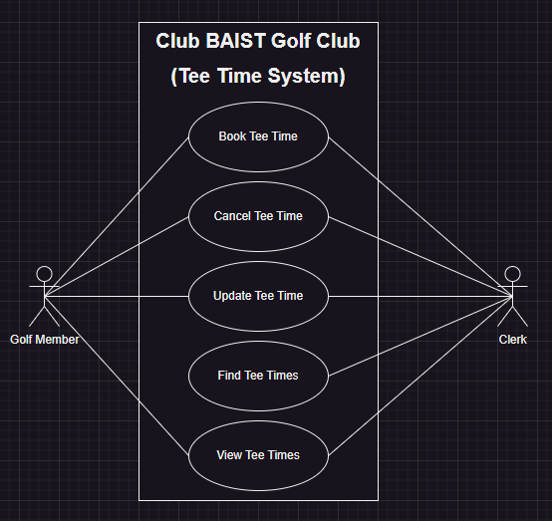

Use Case: Book Tee Time

Brief Description
The purpose of this use case is to allow users to book Tee Times for themselves and possibly for other people.

Flow of Events
Basic Flow: John Doe books for himself
- Choose an amount of time slots to book
- Submit booking times
Alternate Flow: Mary Jane books for John Doe
- Choose an amount of time slots to book
- Assign a user to the booking
- Submit booking times

Special Requirements
Bookings that are a less than a week from now must be booked by a clerk.

Preconditions
Logged in as a member of the golf club and have an active membership or is logged in as a clerk and is helping someone book a Tee Time.
User is currently accessing the system and the relevant page.

Postconditions
The user is notified about the addition of their reservation of the tee time to the system

Other Diagrams
System Sequence Diagrams
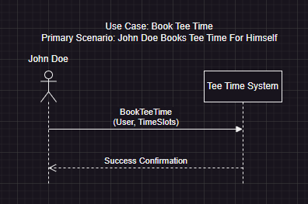
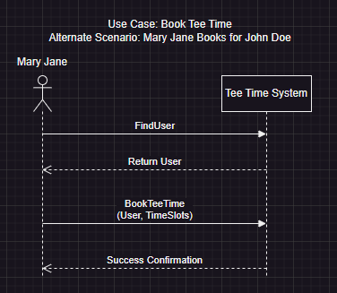
User Interface Prototype
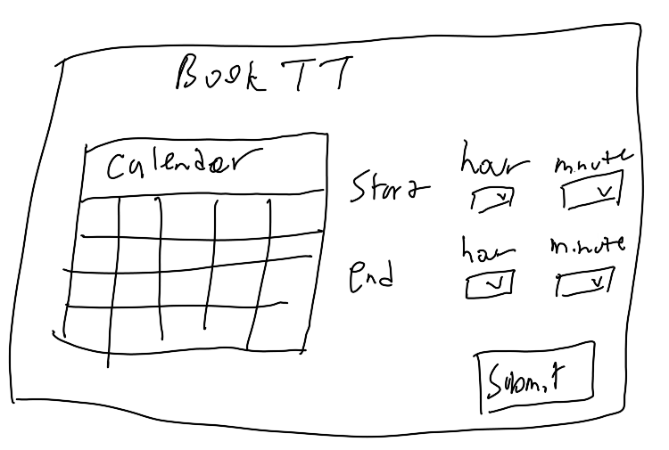

Use Case: Cancel Tee Time

Brief Description
The purpose of this use case is to be able to cancel bookings of Tee Times.

Flow of Events
Basic Flow: John Doe cancels his own Tee Time
- Finds the booking on the page
- Press cancel button
- Confirmation to cancel
Alternate Flow: Mary Jane cancels John Doe’s Tee Time Booking
- Find user’s bookings
- Press cancel button
- Confirmation to cancel
Alternate Flow: Mary Jane cancels a booking for John Doe

Special Requirements
Bookings that are less than a week out need to be done by a clerk

Preconditions
User must be logged in before they can cancel, they also have one or more bookings
User is accessing the relevant page

Postconditions
User is informed that the cancellation was successful/ not successful

Other Diagrams
System Sequence Diagrams
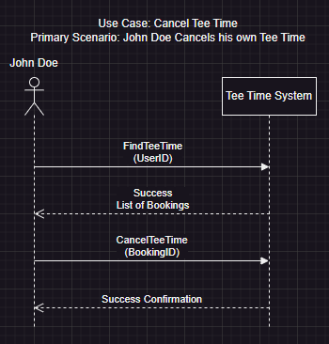
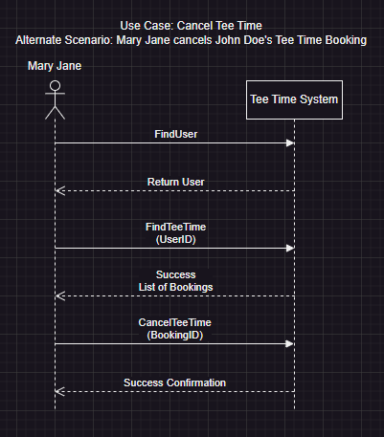
User Interface Prototype
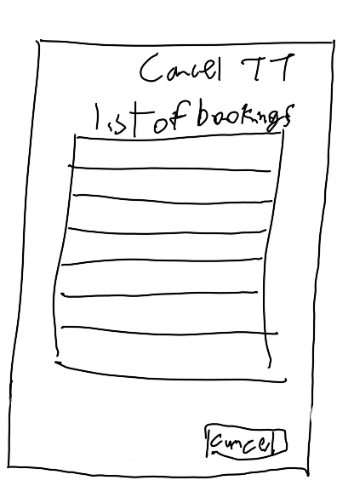

Use Case: Update Tee Time

Brief Description
The purpose of this use case is to have users be able to update the Tee Time like time

Flow of Events
Basic Flow: John Doe updates his Tee Time Booking
- Find the booking
- Press update
- Choose new dates
- Confirmation to update

Special Requirements
Bookings that are less than a week out need to be done by a clerk

Preconditions
The user is logged in and has one or more bookings
User is accessing the relevant page

Postconditions
The user receives a confirmation that the update was successful/ not successful

Other Diagrams
System Sequence Diagrams
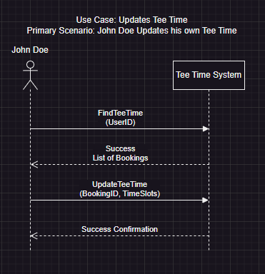
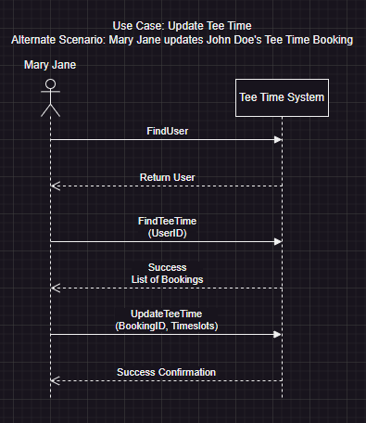
User Interface Prototype
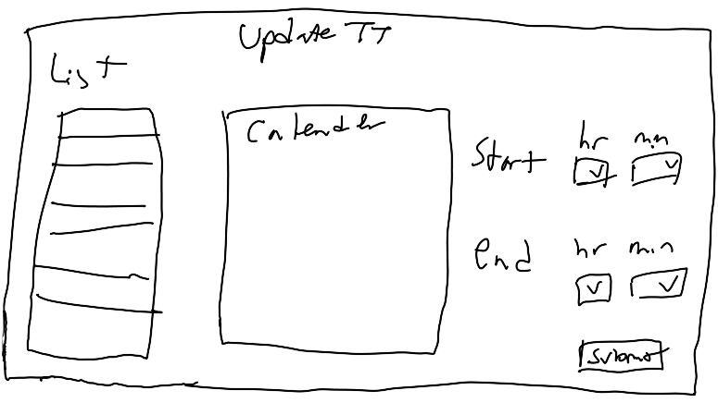

Use Case: Find Tee Time

Brief Description
The purpose of this use case is to find all the Tee Times of a particular user

Flow of Events
Basic Flow: John Doe finds his own Tee Times
- View Tee Times
Alternate Flow: Mary Jane finds John Doe’s Tee Times
- Search up the user
- View their booked tee times

Special Requirements
Members can only use this to find their own booked Tee Times
Clerks and Pro-shop Staff can use this to find another member’s Tee Times.

Preconditions
Person being looked up has an account with the Tee Time system
User must be logged into the system
User must be at the relevant page

Postconditions
After finding the person’s tee times, must show them in an organized manner

Other Diagrams
System Sequence Diagrams
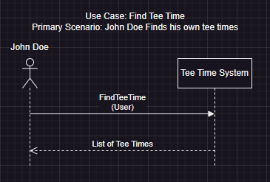
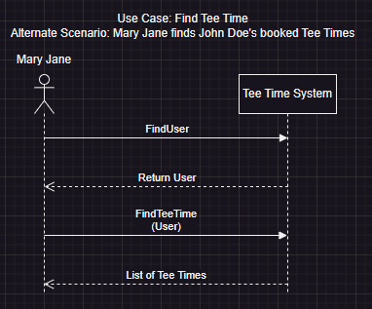
User Interface Prototype
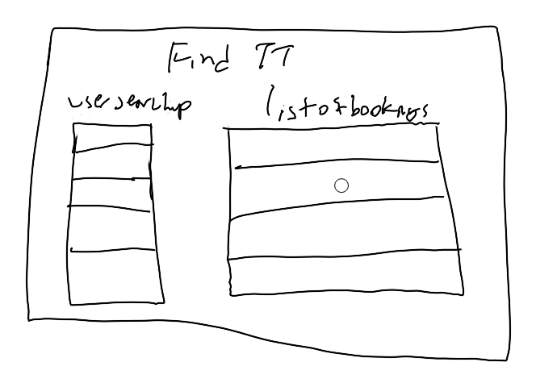

Use Case: View Tee Times

Brief Description
The purpose of this use case is to allow people to view all the bookings for a certain date.

Flow of Events
Basic Flow: John Doe Views the Tee Times
- Choose a date

Special Requirements
None

Preconditions
User must be logged in
User must be accessing the relevant page

Postconditions
User is given the bookings in a quick to read manner
Will also show who is booked for a particular time space

Other Diagrams
System Sequence Diagrams
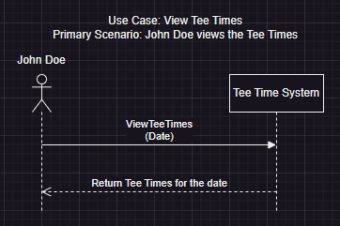
User Interface Prototype
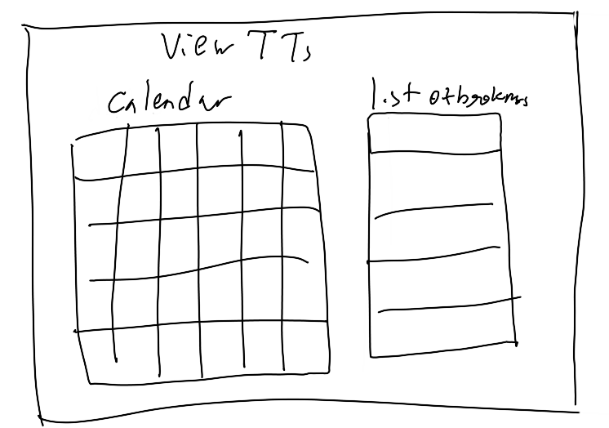

Use Case: Login

Brief Description
The purpose of this use case is to allow users to access their roles by inputting a email and password

Flow of Events
Basic Flow: John Doe Logs In
- Enter Valid Email
- Enter Valid Password
- Submit

Special Requirements
none

Preconditions
The user must not be logged in already
A account with the associated email address exists

Postconditions
The user must have a secure cookie with their essential information in their browser.

Other Diagrams
System Sequence Diagram
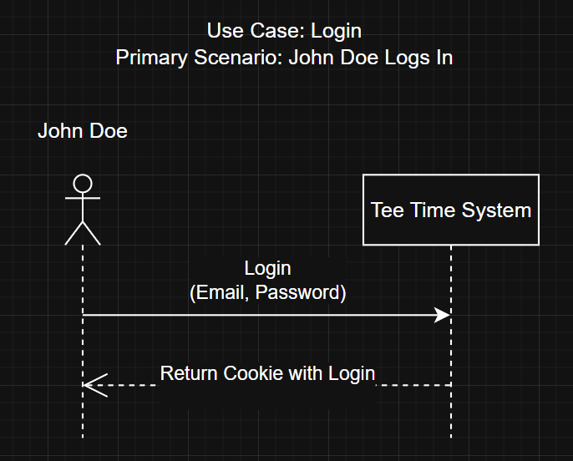
User Interface Prototype
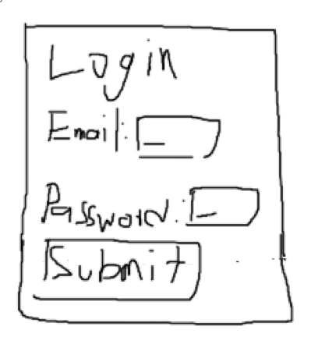

Use Case: Register

Brief Description
The purpose of this use case is to allow users to register for an account

Flow of Events
Basic Flow: John Doe Registers an Account
- Enter Email
- Enter Password, confirm password
- Enter First name and last name
- Enter phone number
- Enter address, city, province, postalcode
- Press submit

Special Requirements
None

Preconditions
User must not be already logged in
An account with the same email address does not already exist

Postconditions
New account must be made

Other Diagrams
System Sequence Diagram
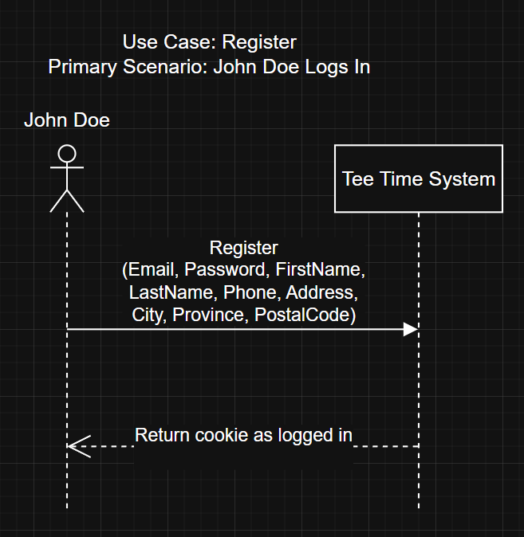
User Interface Prototype
